*The Dark Knight* (2008)

*NOTE: this is the second in the Batman Trilogy, directed by Christopher Nolan. The first film was *Batman Begins* (2005), and the third film was *The Dark Knight Rises* (2012).

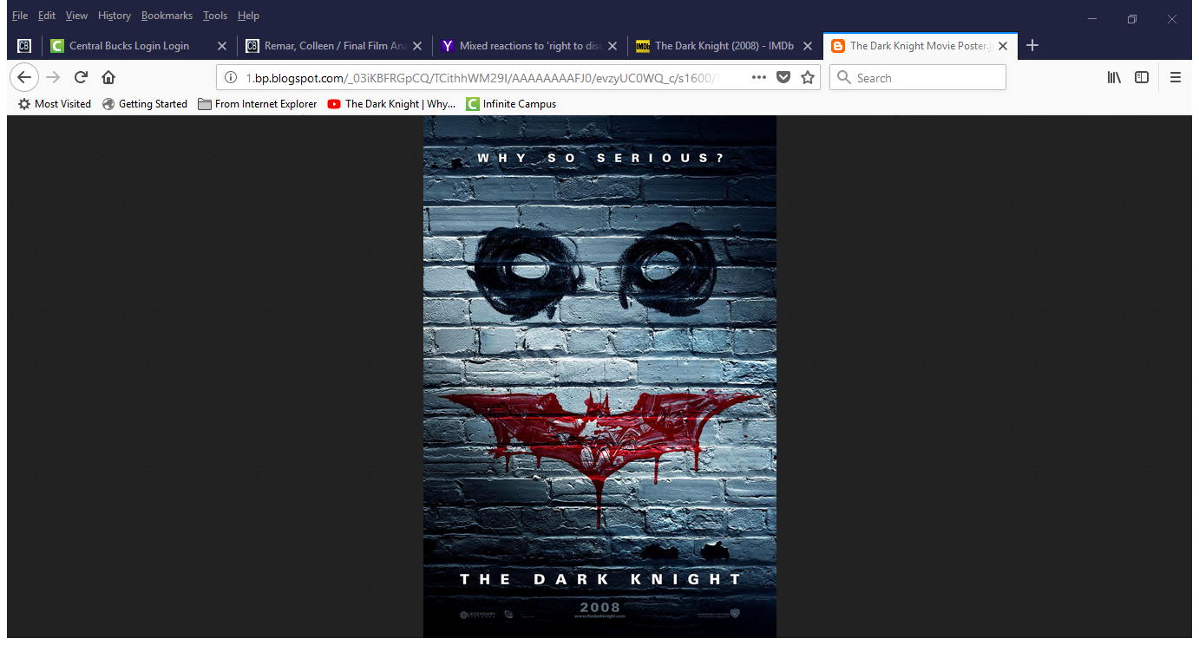

**SCREENPLAY** by Jonathan and Christopher Nolan

**CAST:**

Christian Bale Bruce Wayne/Batman

Heath Ledger Joker

Aaron Eckhart Harvey Dent

Michael Caine Alfred

Maggie Gyllenhaal Rachel Dawes

Gary Oldman Chief Gordon

Morgan Freeman Lucius Fox

Nominated for 8 Oscars—there were 2 wins:

* Heath Ledger (posthumously awarded) for Best Performance by an Actor in a Supporting Role
* Richard King for Best Achievement in Sound Editing

*The Dark Knight* (2008)

*NOTE: this is the second in the Batman Trilogy, directed by Christopher Nolan. The first film was *Batman Begins* (2005), and the third film was *The Dark Knight Rises* (2012).



**SCREENPLAY** by Jonathan and Christopher Nolan

**CAST:**

Christian Bale Bruce Wayne/Batman

Heath Ledger Joker

Aaron Eckhart Harvey Dent

Michael Caine Alfred

Maggie Gyllenhaal Rachel Dawes

Gary Oldman Chief Gordon

Morgan Freeman Lucius Fox

Nominated for 8 Oscars—there were 2 wins:

* Heath Ledger (posthumously awarded) for Best Performance by an Actor in a Supporting Role
* Richard King for Best Achievement in Sound Editing f

*The Dark Knight* (2008)